**Personas:**

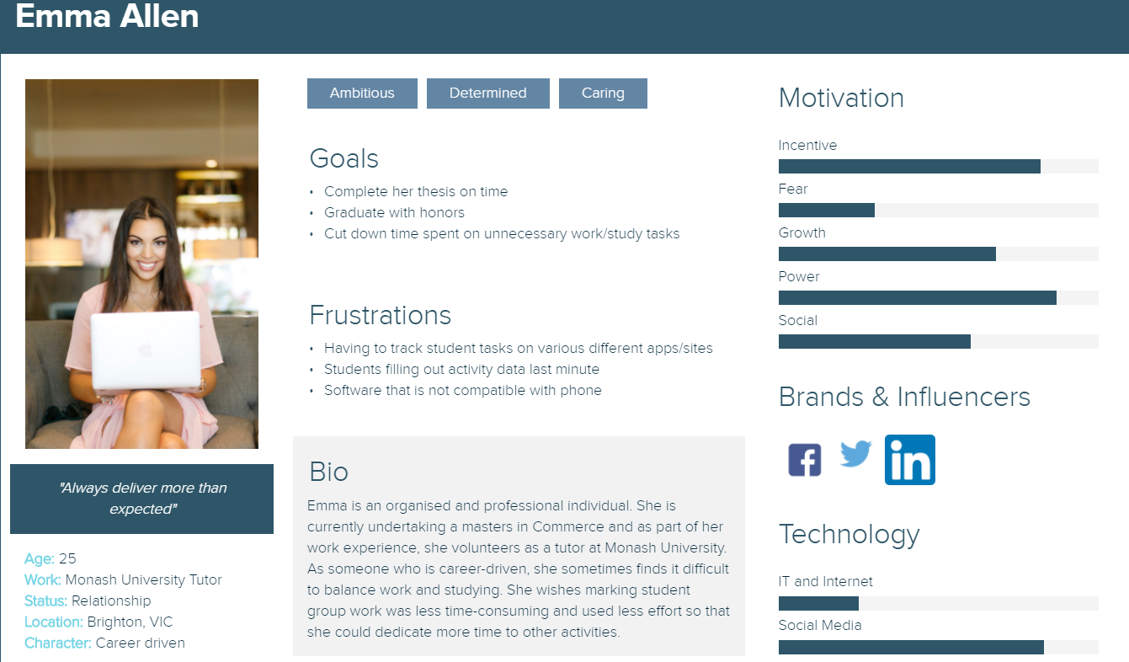

**Story map:**

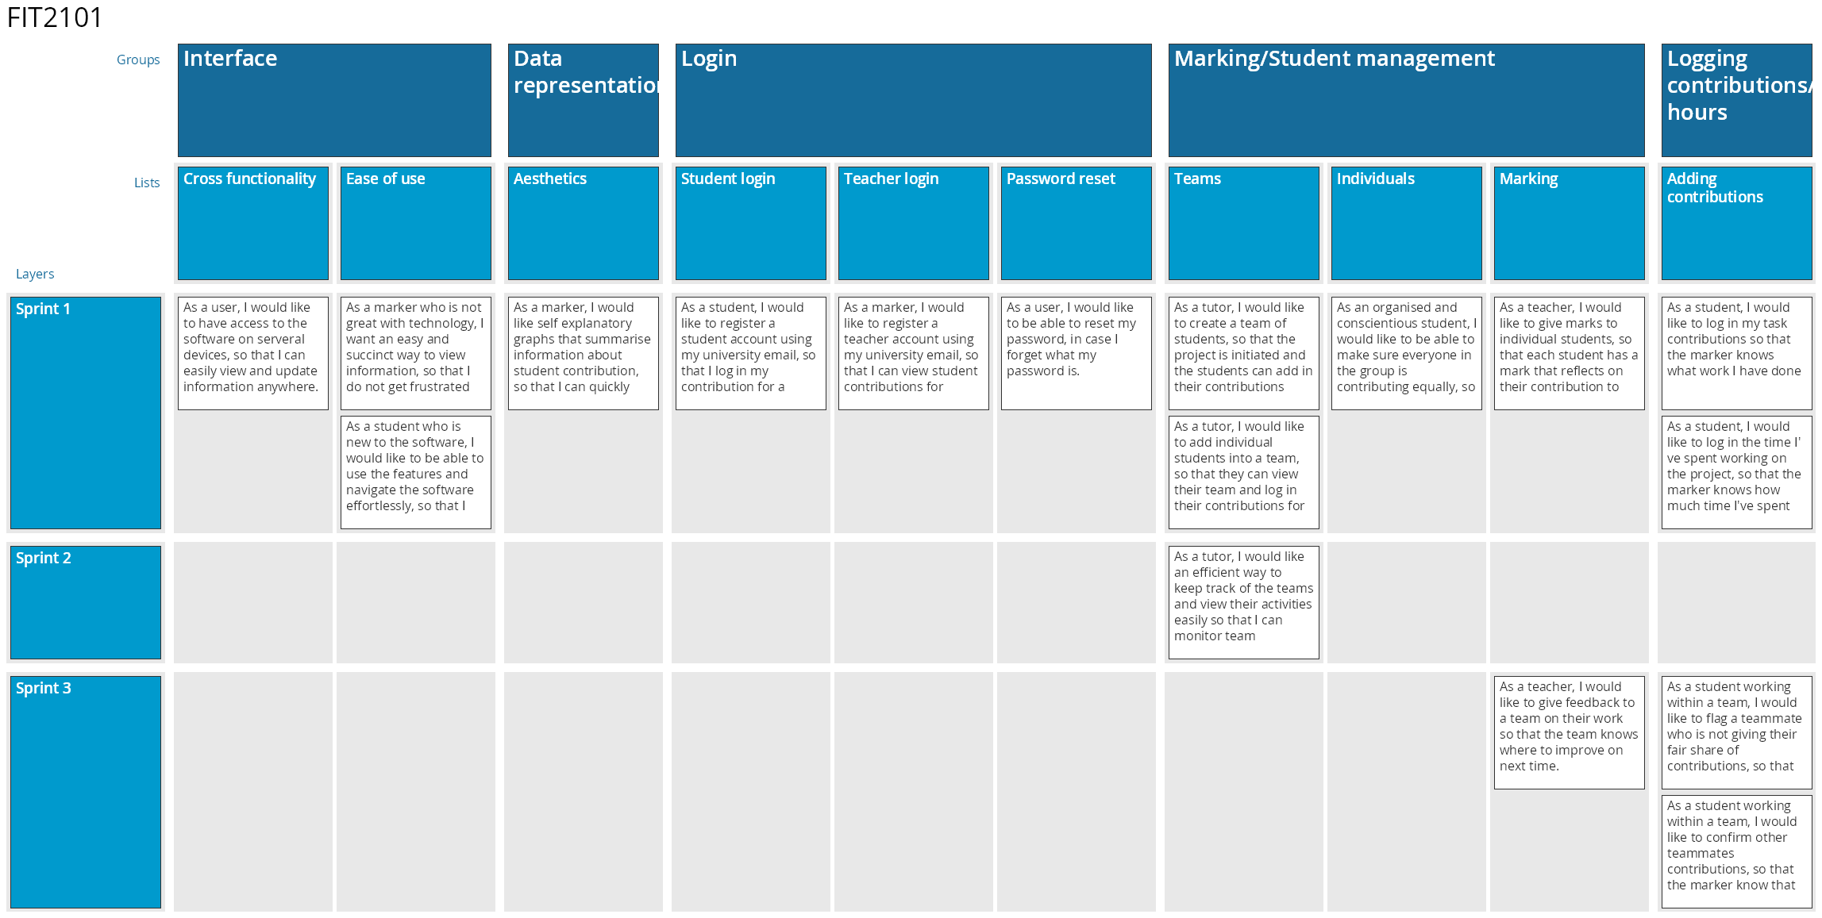

**User Stories:**

1. **Interface:**

* 1. **Cross functionality:** 
     1. As a user, I would like to have access to the software on several devices, so that I can easily view and update information anywhere.
  2. **Ease of use:**
     1. As a marker who is not great with technology, I want an easy and succinct way to view information, so that I do not get frustrated when marking student assignments.
     2. As a student who is new to the software, I would like to be able to use the features and navigate the software effortlessly, so that I save time when using it along side my project

1. **Data representation:**
   1. **Aesthetics:** 
      1. As a marker, I would like self explanatory graphs that summarise information about student contribution, so that I can quickly understand the team contributions.
2. **Login:**
   1. **Student Login:**
      1. As a student, I would like to register a student account using my university email, so that I log in my contribution for a project
   2. **Teacher Login:**
      1. As a marker, I would like to register a teacher account using my university email, so that I can view student contributions for projects under my management.
   3. **Password Reset:**
      1. As a user, I would like to be able to reset my password, in case I forget what my password is.
3. **Marking/Student Management:**
   1. **Teams:**
      1. As a tutor, I would like an efficient way to keep track of the teams and view their activities easily so that I can monitor team performance and ensure fairness in the projects.
      2. As a tutor, I would like to add individual students into a team, so that they can view their team and log in their contributions for that team.
   2. **Marking:**
      1. As a teacher, I would like to give marks to individual students, so that each student has a mark that reflects on their contribution to the project.
4. **Logging Contribution/Hour:**
   1. **Adding Contribution/Hour:**
      1. As a student, I would like to log in my task contributions so that the marker knows what work I have done.
      2. As a student, I would like to log in the time I've spent working on the project, so that the marker knows how much time I've spent on the project.
      3. As a student working within a team, I would like to flag a teammate who is not giving their fair share of contributions, so that markers know of this information.
      4. As a student working within a team, I would like to confirm other teammates' contributions, so that the marker knows that we are all being honest.
      5. As a tutor, I do not want students to change their contributions from past dates, to ensure students log in their contributions on the day they work on it.

**PRODUCT BACKLOG:**

| **STORY** | **ESTIMATION** | **PRIORITY** |
| --- | --- | --- |
| Wireframes | Small | 0 |
| As a student I would like to register a user account using my student email | Medium | 1 |
| As a marker, I would like to register a teacher account using my university email, | Extra small | 2 |
| As a user, I would like to be able to reset my password | Medium | 3 |
| As a tutor, I would like to add individual students into a team, so that they can view their team and log in their contributions for that team. | Large | 4 |
| As a student, I would like to log in my task contributions so that the marker knows what work I have done | Extra large | 5 |
| As a tutor, I would like an efficient way to keep track of the teams and view their activities easily so that I can monitor team performance and ensure fairness in the projects | Large | 6 |
| As a student, I would like to log in the time I've spent working on the project, so that the marker knows how much time I've spent on the project | Medium | 7 |
| As a tutor, I do not want students to change their contributions from past dates, to ensure students log in their contributions on the day they work on it. | Small | 8 |
| As a student working within a team, I would like to confirm other teammates' contributions, so that the marker knows that we are all being honest. | small | 9 |
| As a student working within a team, I would like to flag a teammate who is not giving their fair share of contributions, so that markers know of this information | small | 10 |
| As a teacher, I would like to give marks to individual students, so that each student has a mark that reflects on their contribution to the project | Medium | 11 |
| As a marker, I would like self explanatory graphs that summarise information about student contribution, so that I can quickly understand the team contributions. | Large | 12 |
| As a student who is new to the software, I would like to be able to use the features and navigate the software effortlessly, so that I save time when using it along side my project | Medium | 13 |
| As a marker who is not great with technology, I want an easy and succinct way to view information, so that I do not get frustrated when marking student assignments. | Medium | 14 |
| As a user, I would like to have access to the software on several devices, so that I can easily view and update information anywhere. | Medium | 15 |
| **Total** |  |  |

**SCALING SYSTEM:**

XS - Less than an hour

S - A few hours

M - A day or so

L - A week or so

XL - More than a week